Task 2 – Flow Chart

Unedited Version

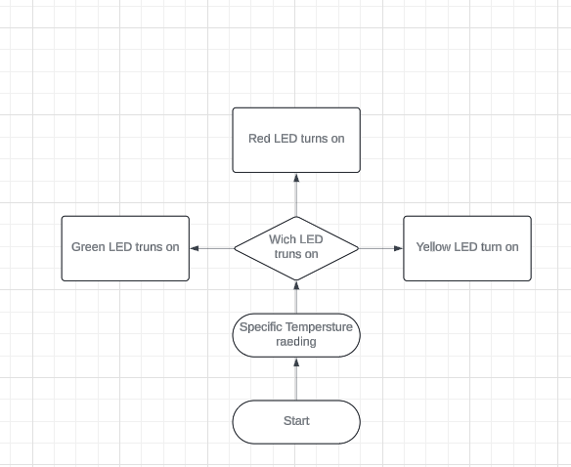

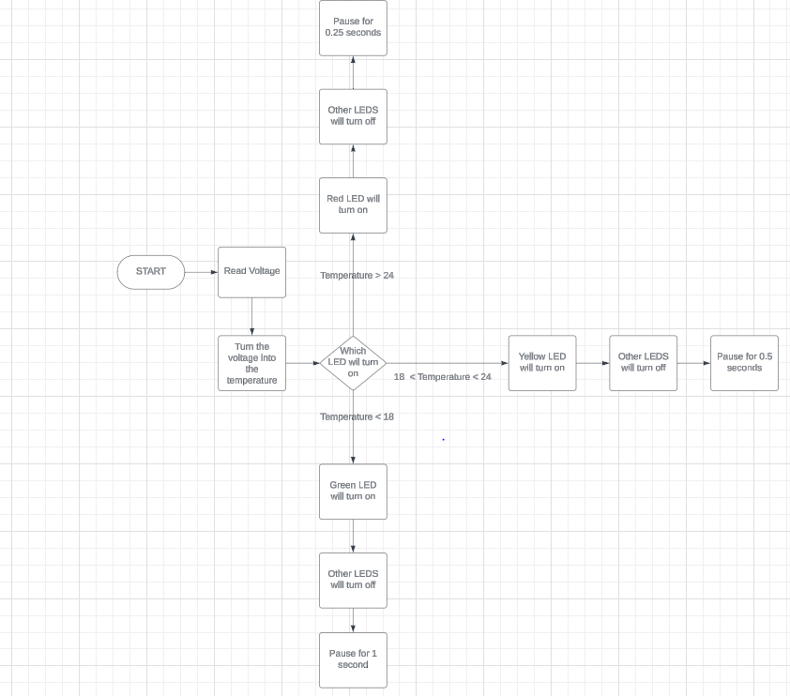Complete Version (After coding)

Task 3 – Flow Chart (Before Coding)

